\
Get Clean Starter Kit
All you need to start cleaning your way to a healthier home
Convenient online ordering and home delivery at:

Order your Get Clean Starter Kit today
and you’ll also enjoy a FREE Shaklee Membership
giving you many discounts and benefits
---with absolutely no obligations.

Got Questions? I’m here to help!

Get Clean Starter Kit
All you need to start cleaning your way to a healthier home
Convenient online ordering and home delivery at:

Order your Get Clean Starter Kit today
and you’ll also enjoy a FREE Shaklee Membership
giving you many discounts and benefits
---with absolutely no obligations.

Got Questions? I’m here to help!

Over 80,000 chemicals have been registered with the EPA in the last 30 years.
Fewer than 500 of these chemicals
have ever been tested for toxicity.
And of those 500,
NONE have been tested
when combined with another chemical.

The result?

Over 80,000 chemicals have been registered with the EPA in the last 30 years.
Fewer than 500 of these chemicals
have ever been tested for toxicity.
And of those 500,
NONE have been tested
when combined with another chemical.

The result?

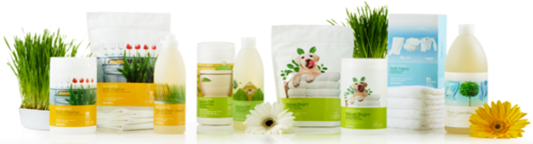

Your Get Clean Starter Kit saves you $3,000+ and includes:
- Dishwasher Automatic Powder Concentrate (plus dispenser)
- Hand Dish Wash Liquid Concentrate
- Germ Off Disinfecting Wipes
- Basic-H² 16 oz. bottle (for every household cleaning chore)
- Nature Bright Laundry Booster & Stain Remover (plus dispenser)
- Soft Fabric Dryer Sheets
- Fresh Laundry Fragrance Free Concentrate (HE Compatible)
- Plus all of the Get Clean accessories: 3-pk spray bottle, dropper pipette,
pump for 32 oz laundry bottle, measuring scoop, dual measuring spoon, Super Microfiber Cleaning Cloth, Super Microfiber Window Cloth,
Super Microfiber Dish Sponge, Miracle Scrubber Pad and Cleaning Caddy

Your Get Clean Starter Kit saves you $3,000+ and includes:
- Dishwasher Automatic Powder Concentrate (plus dispenser)
- Hand Dish Wash Liquid Concentrate
- Germ Off Disinfecting Wipes
- Basic-H² 16 oz. bottle (for every household cleaning chore)
- Nature Bright Laundry Booster & Stain Remover (plus dispenser)
- Soft Fabric Dryer Sheets
- Fresh Laundry Fragrance Free Concentrate (HE Compatible)
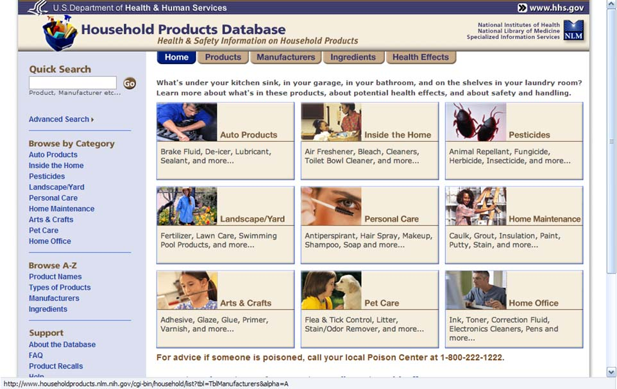
- Plus all of the Get Clean accessories: 3-pk spray bottle, dropper pipette,
pump for 32 oz laundry bottle, measuring scoop, dual measuring spoon, Super Microfiber Cleaning Cloth, Super Microfiber Window Cloth,
Super Microfiber Dish Sponge, Miracle Scrubber Pad and Cleaning Caddy
The Shaklee Difference…
We believe that health isn't just about what you put in your body, it's about everything around you. We also believe in being in harmony with Nature and Good Health™. That’s why we bring you a full line of natural and nontoxic cleaning choices that are Safe for You, Your Home, & Your Planet®, Get Clean®.
- No harmful fumes or hazardous chemicals.
- Outperforms 20 national leading brands.
- You would spend $3400 for ready to use cleaners to get the same
amount of clean found in the Get Clean Starter Kit!
- Features Basic H2® Organic Super Cleaning Concentrate
- just 1/4 tsp. makes 16 oz. of all-purpose cleaner for only 3cents.
- And when you purchase the Get Clean Starter Kit you also make a positive impact on the planet:
Keep 108 pounds of packaging waste from landfills.
Eliminate 248 pounds of greenhouse gas.

The Shaklee Difference…
We believe that health isn't just about what you put in your body, it's about everything around you. We also believe in being in harmony with Nature and Good Health™. That’s why we bring you a full line of natural and nontoxic cleaning choices that are Safe for You, Your Home, & Your Planet®, Get Clean®.
- No harmful fumes or hazardous chemicals.
- Outperforms 20 national leading brands.
- You would spend $3400 for ready to use cleaners to get the same
amount of clean found in the Get Clean Starter Kit!
- Features Basic H2® Organic Super Cleaning Concentrate
- just 1/4 tsp. makes 16 oz. of all-purpose cleaner for only 3cents.
- And when you purchase the Get Clean Starter Kit you also make a positive impact on the planet:
Keep 108 pounds of packaging waste from landfills.
Eliminate 248 pounds of greenhouse gas.

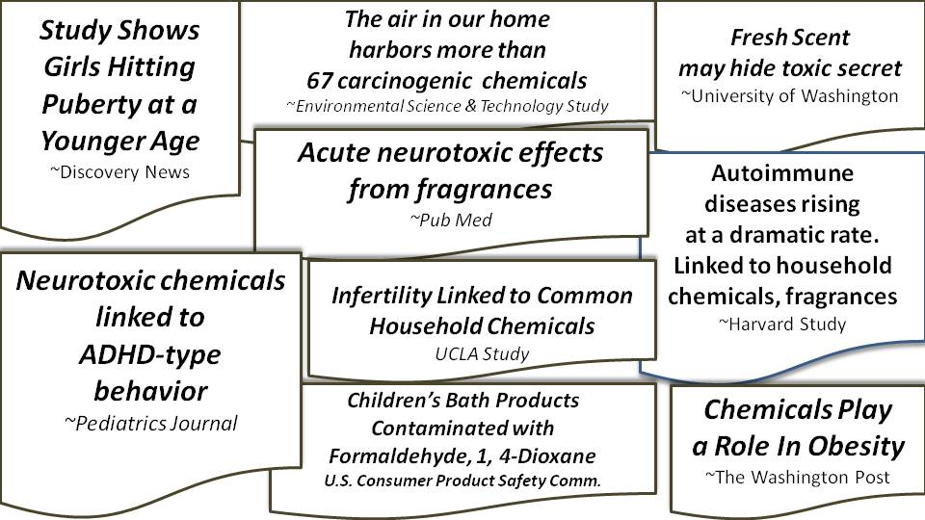

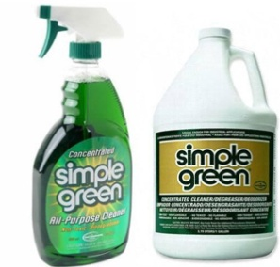
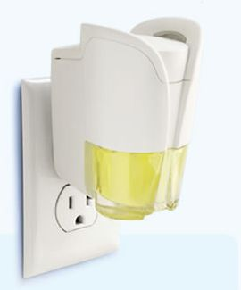
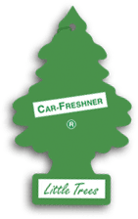
According to The Cleveland Clinic
Air Fresheners contain:
Formaldehyde: A strong irritant to the eyes, throat,
skin and lungs; thought to cause cancer
Petroleum distillates: Can irritate skin, eyes,
respiratory tract; may cause fatal pulmonary edema;
Highly flammable Fumes are associated with brain damage

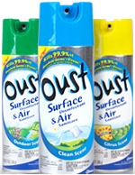
HAVE YOU EVER READ THE LABEL?
“HAZARDOUS TO HUMANS AND DOMESTIC ANIMALS:
“Before spraying, remove birds.”
“Before using product throughout your home,
use in one room and wait 24 hours
to ensure that no one has any
physical reactions to the product”

According to The Cleveland Clinic
Air Fresheners contain:
Formaldehyde: A strong irritant to the eyes, throat,
skin and lungs; thought to cause cancer
Petroleum distillates: Can irritate skin, eyes,
respiratory tract; may cause fatal pulmonary edema;
Highly flammable Fumes are associated with brain damage

HAVE YOU EVER READ THE LABEL?
“HAZARDOUS TO HUMANS AND DOMESTIC ANIMALS”
“Before spraying, remove birds”.
“Before using product throughout your home,
use in one room and wait 24 hours
to ensure that no one has any
physical reactions to the product”
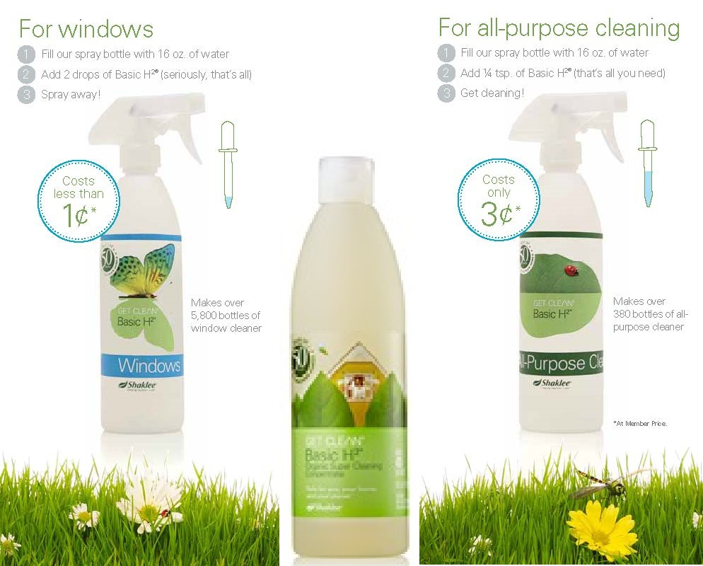
Basic H²
Multi-Purpose, The Original Green Cleaner
Basic H²
Multi-Purpose, The Original Green Cleaner

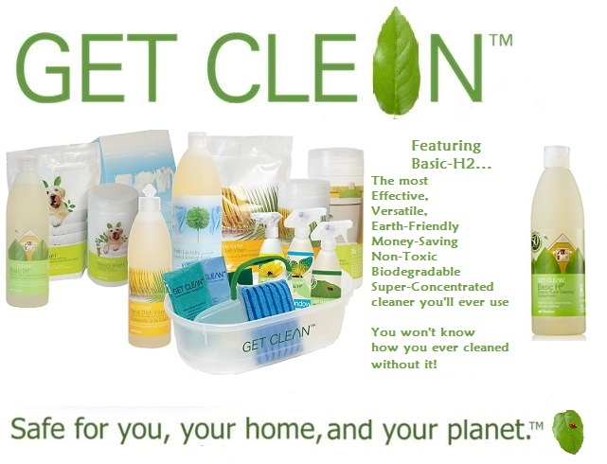

The following information on common products,
their chemical ingredients and potential side effects was compiled from information on these two government websites:
EPA.gov Environmental Protection Agency
& The National Institute of Health http://householdproducts.nlm.nih.gov/
NIH Household Product Database

The following information on common products,
their chemical ingredients and potential side effects was compiled from information on these two government websites:
EPA.gov Environmental Protection Agency
& The National Institute of Health http://householdproducts.nlm.nih.gov/
NIH Household Product Database

CHLORINE
Can cause severe skin and eye damage
Damaging to the respiratory tract
Corrosive and damaging to cells on contact
Causes throat irritation even when exposed briefly
& even at low levels

Linked to RADS:
Reactive Airways Dysfunction Syndrome
Bronchitis Asthma

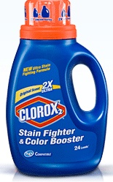
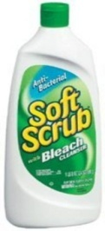
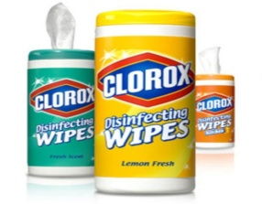
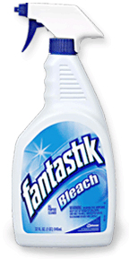
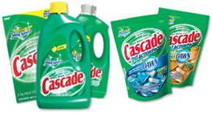

CHLORINE
Can cause severe skin and eye damage
Damaging to the respiratory tract
Corrosive and damaging to cells on contact
Causes throat irritation even when exposed briefly
& even at low levels

Linked to RADS:
Reactive Airways Dysfunction Syndrome
Bronchitis Asthma

Over 90% of poison exposures happen at home.
Chlorine bleach is the #1 household chemical involved in poisonings.
Common cleaners give off fumes that can potentially increase the risk
of kids developing asthma, the most common chronic childhood
disease. 1 in 13 school-aged children has asthma. Rates in children
under 5 increased more than 160% from 1980 –1994.
If your home is anything like the average U.S. home, you generate
more than 20 pounds of household hazardous waste each year
(the EPA designates toilet cleaners, tub and tile cleaners, oven
cleaners, and bleach as hazardous waste).

Over 90% of poison exposures happen at home.
Chlorine bleach is the #1 household chemical involved in poisonings.
Common cleaners give off fumes that can potentially increase the risk
of kids developing asthma, the most common chronic childhood
disease. 1 in 13 school-aged children has asthma. Rates in children
under 5 increased more than 160% from 1980 –1994.
If your home is anything like the average U.S. home, you generate
more than 20 pounds of household hazardous waste each year
(the EPA designates toilet cleaners, tub and tile cleaners, oven
cleaners, and bleach as hazardous waste).

MEA (MONOETHANOLAMINE)
Can cause Liver Damage
Directly linked to Asthma
Can cause immediate allergic responses
Irritating to eyes, skin and lungs
Causes symptoms associated with:
Central Nervous System Depression
Memory loss Impaired thinking
Depression Mood Swings
Fatigue Inability to complete tasks

FORMALDEHYDE & 1, 4-DIOXANE
Formaldehyde is a preservative 1, 4-Dioxane is a byproduct of combining chemicals

Both are known carcinogens Both are banned in other countries in many products so companies like J & J make two formulas
Impairs immune function (asthma, cancer)
Symptoms may include:
Eye, Nose & Throat Irritation Wheezing Coughing Fatigue
Skin rash Eczema Severe allergic reactions

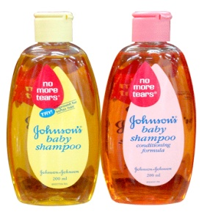
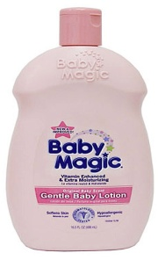
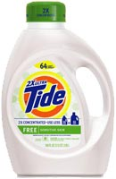
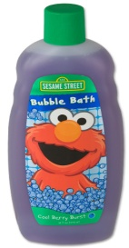
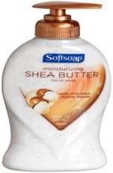
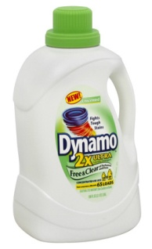
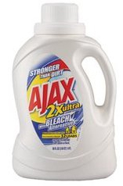
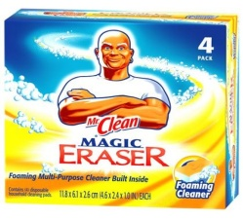
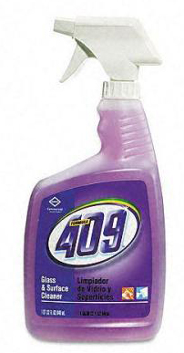
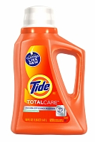
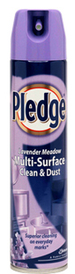
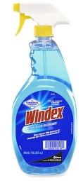
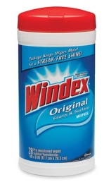

FORMALDEHYDE & 1, 4-DIOXANE
Formaldehyde is a preservative 1, 4-Dioxane is a byproduct of combining chemicals

Both are known carcinogens Both are banned in other countries in many products so companies like J & J make two formulas
Impairs immune function (asthma, cancer)
Symptoms may include:
Eye, Nose & Throat Irritation Wheezing Coughing Fatigue
Skin rash Eczema Severe allergic reactions

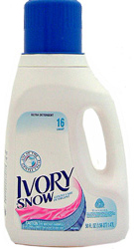
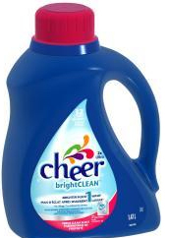
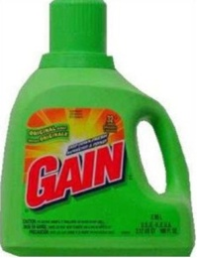
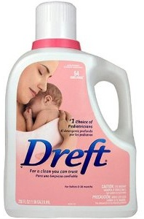

MEA (MONOETHANOLAMINE)
Can cause Liver Damage
Directly linked to Asthma
Can cause immediate allergic responses
Irritating to eyes, skin and lungs
Causes symptoms associated with:
Central Nervous System Depression
Memory loss Impaired thinking
Depression Mood Swings
Fatigue Inability to complete tasks

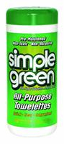
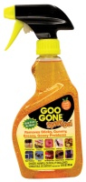
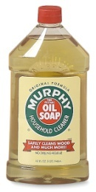
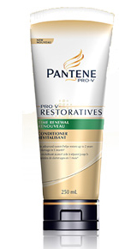
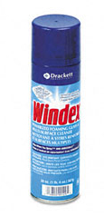
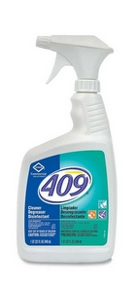
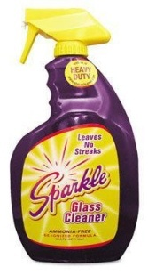
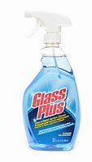
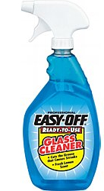
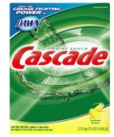
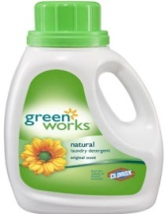
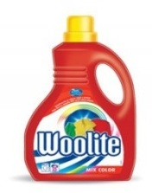
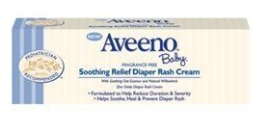
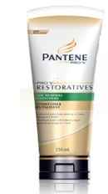
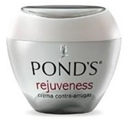
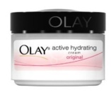
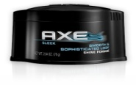
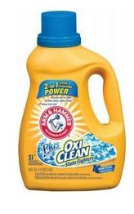
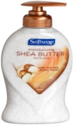
BUTYL CELLOSOLVE

Probable Carcinogen (Cancer-causing)
& Linked to Reproductive Harm
Irritating to the skin and respiratory system
Exposure for 15 minutes = 3x limit
Symptoms include: Fatigue Weakness
Impaired thinking Drowsines Memory loss Depression Headaches Mood swings
Inability to complete tasks Personality changes

LYE
(Caustic metallic base)
aka Sodium Hydroxide, Potassium Hydroxide
May cause irritation to the respiratory tract and liver & kidney damage
Irritating to skin & eyes
May cause chronic skin irritation
Repeated contact may cause dermatitis (eczema)
Causes 75% of all caustic injury to kids less than 5 yrs.

BUTYL CELLOSOLVE

Probable Carcinogen (Cancer-causing)
& Linked to Reproductive Harm
Irritating to the skin and respiratory system
Exposure for 15 minutes = 3x limit
Symptoms include: Fatigue Weakness
Impaired thinking Drowsines Memory loss Depression Headaches Mood swings
Inability to complete tasks Personality changes

LYE
(Caustic metallic base)
aka Sodium Hydroxide, Potassium Hydroxide
May cause irritation to the respiratory tract and liver & kidney damage
Irritating to skin & eyes
May cause chronic skin irritation
Repeated contact may cause dermatitis (eczema)
Causes 75% of all caustic injury to kids less than 5 yrs.

